**Release] How to change stat points per level and working stat resets**

A tutorial on how to change Ultimate Mode stat points and make stat resets give the changed stats back  
  
Things you will need.  
  
ollydbg 2.0 - http://www.ollydbg.de/odbg200.zip  
ps_game.exe not to be confused with game.exe can be found in server folder   
SHAIYA_SERVER\SERVER\PSM_Client\Bin  
  
Make a back up of your ps_game.exe before you edit it just incase you make a mistake.  
  
Open ollydbg  
  
Browse to your ps_game.exe and open it  
  
First thing we need to do is change the stat points you get when you level up.  
  
So right click on main window then go to then expression.

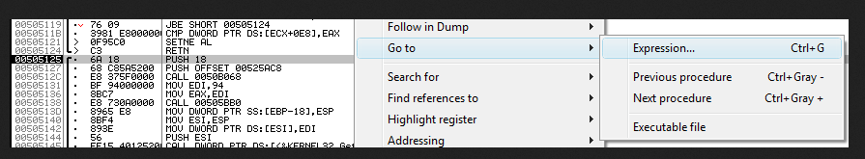

Now enter this in the expression box 0048A6A2 and click ok after it finds it you will end up with this.  
  
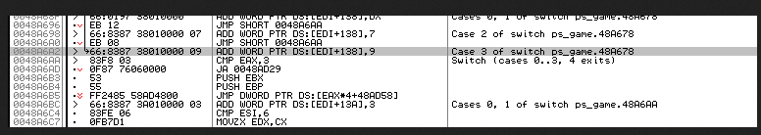  
  
Now if you look at the line with the grey covering it you will see this  
  
ADD WORD PTR DS:[EDI+138],9  
  
For the people who have not already guessed what the 9 is it is the 9 stat points you get every time you level up so we need to change it to what ever stat points you want but remember you need to use the Hex values when changing so 10=A 11=B 12=C 13=D and so on.  
  
To change it double click on ADD WORD PTR DS:[EDI+138],9  
You will end up with this.

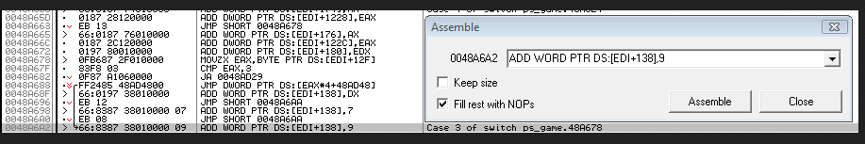

.  
Delete the 9 and put the hex value you want   
I will be using 0D which is 13 stat points a level after you press the assemble button your main window should look like this.  
  
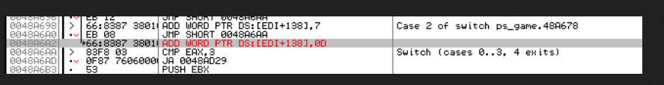  
  
Now that is done we need to make stat resets give the right amount of stat points when used.  
To start you will need to search for a expression again and enter this 0048088C you should end up with this.  
  
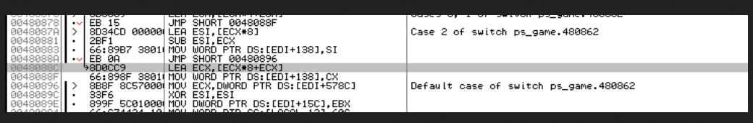  
  
All you need to do is change lea ecx,[ecx*8+ecx] to IMUL ECX, ECX, 0D or what ever stat points you choose.  
  
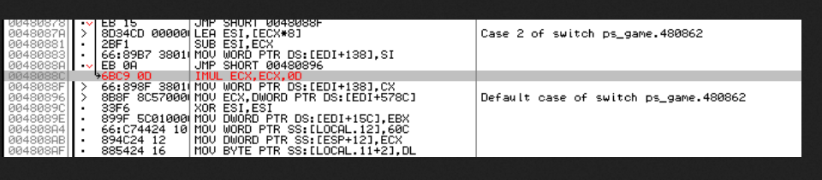  
  
A big thank you to lilprohacker for the helpfull hint.  
  
For people wanting to change the skill points here is the addresses of them and what the code looks like i will leave it up to you to change them.  
  
These are for Ultimate Mode.  
  
0048aaa8 - ADD WORD PTR DS:[EDI+13A],DX < This one is how many skill points per level DX = 5 and yes you can change it to a number.  
00480c30 - LEA EDX,[EAX*4+EAX+5] < This one is the points you get when you use a skill reset + 5 you get at the start of the game  
  
Have fun with your new stat points and working stat resets.  
  
Jason aka -AJ-